UEEN2013/UEEN3423 TCP/IP Network Fundamentals

Lab 05: Internet Protocol version 6 (IPv6)

Instructions:
- Perform case study #1 & #2 with Packet Tracer
- Perform case study #3 & #4 with GNS3.
- First two case studies are not guided, and you are required to design these networks based on the specifications and the hints.

Exercise 1: IPv6 Network with Static Routing

Build a network based on figure below with the following specifications. Use Cisco 1841 router:
- No IPv4 address is allowed.
- Configure every IP address in IPv6 (static IPv6).
- Remember to set static routes.
- Configure the DNS server and Web server in IPv6. Make sure that DNS has a look up entry of “uccn2003.edu” to the IPv6 address of the Web server.
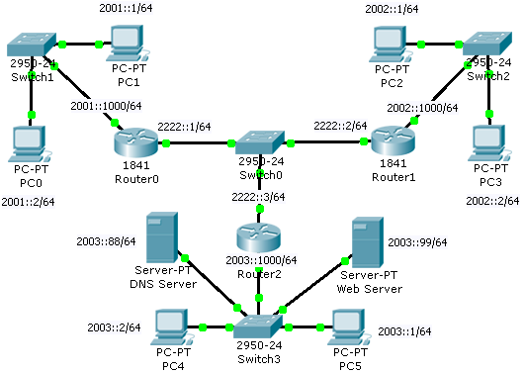

Assessment criteria:
- Every PC can ping each other. (For example, go to the command prompt of a PC and type “ping 2003::1”).
- PC can access the Web server via “http://uccn2003.edu”

Hints on configuring an IPv6 address on an interface of a router:
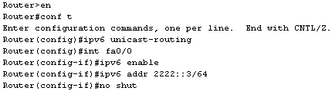

- “ipv6 unicast-routing” is to enable the forwarding of IPv6 unicast datagrams globally on the router. This command is a must before any IPv6 operation. You only need to key in this command once for every router.
- “ipv6 enable” has to be done once for each IPv6 interface. It is a must for any IPv6 operation in an interface.
- “2222::3” is the IPv6 address. /64 is the IPv6 subnet mask (64 bits long).
- 2222::3 = 2222:0000:0000:0000:0000:0000:0000:0003
- Network ID for 2222::3/64 is 2222::
- Use “show ipv6 int br” to check the ipv6 address in the interfaces.
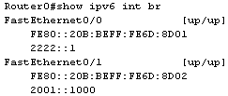
- Use “show run” to help you troubleshoot the router.

Hints on configuring an IPv6 address on a PC (and server):

- Go to “Config” tab → “FastEthernet” and key in the IPv6 address with the subnet mask. Press the selection to “Static”
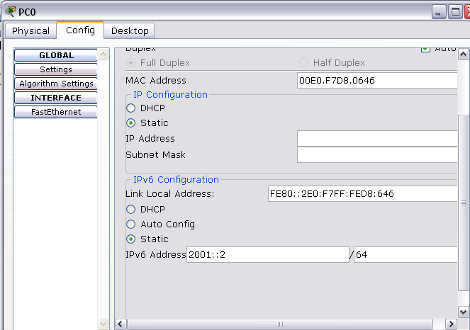
- Go to the “Config” tab → “Settings” and key in the IPv6 Gateway and IPv6 DNS server IP.
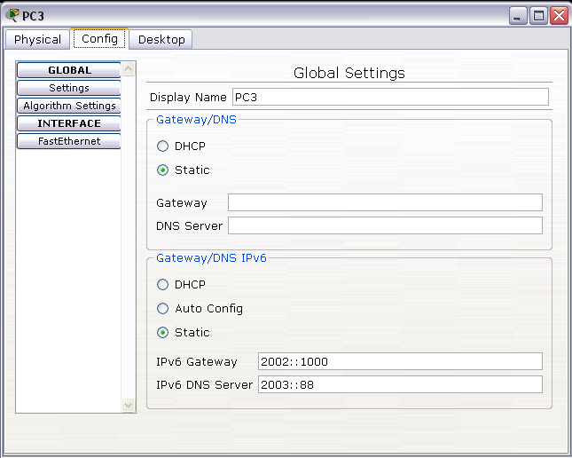

- You may go to the command prompt and type “ipv6config /all” to check the ipv6 addresses, once you have configured them.
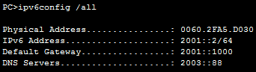

Hints on configuring an IPv6 static routes:
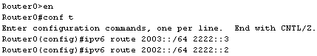

- Type “ipv6 route destination_network next_hop”.
- The above example shows the static route for Router0. “2003::/64” is the network ID. 2222::3 is the next hop IPv6 address.
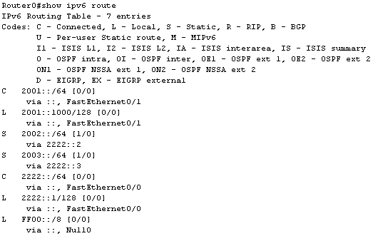
- Use “show ipv6 route” to check the ipv6 routing table.

Exercise 2: IPv6 Dynamic Routing with RIP

Build a network based on figure below with the following specifications. Use Cisco 1841 & 2811 router:
- All the IPv6 addresses are in eui-64 format.
- Use IPv6 RIP routing protocol.

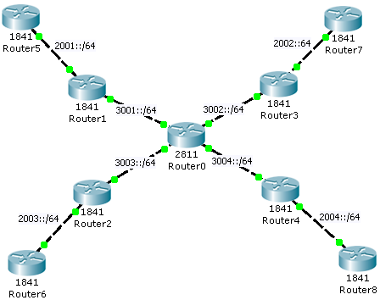
Assessment criteria:
- Router6 can ping every IPv6 interface.
- Every IPv6 must be in eui-64 format.
- Router6 must have a valid routing table (with routing code ‘R’)

Hints on setting up IPv6 eui-64 address and RIP:
- Refer to the following running-configuration. Try to understand the configuration and turn it into commands for each router.
Router0#show run  Building configuration...  !  version 12.4  no service password-encryption  !  hostname Router0  !  ipv6 unicast-routing  !  interface FastEthernet0/0  no ip address  duplex auto  speed auto  ipv6 address 3001::/64 eui-64  ipv6 mtu 1500  ipv6 rip NET enable  ipv6 enable  !  interface FastEthernet0/1  no ip address  duplex auto  speed auto  ipv6 address 3003::/64 eui-64  ipv6 mtu 1500  ipv6 rip NET enable  ipv6 enable  ! | interface FastEthernet1/0  no ip address  duplex auto  speed auto  ipv6 address 3002::/64 eui-64  ipv6 mtu 1500  ipv6 rip NET enable  ipv6 enable  !  interface FastEthernet1/1  no ip address  duplex auto  speed auto  ipv6 address 3004::/64 eui-64  ipv6 rip NET enable  !  ipv6 router rip NET  !
Exercise 3: IPv6 Tunneling

Build a network based on figure below with the following specificatios.

- IPv6 subnet 2001::/64 can communicate with IPv6 subnet 2001:999::/64 via an IPv6 tunnel in the IPv4 subnet 200.1.1.1/24.
- Qemu1 can ping Qemu3 using IPv6 address, with an IPv4 subnet in between.
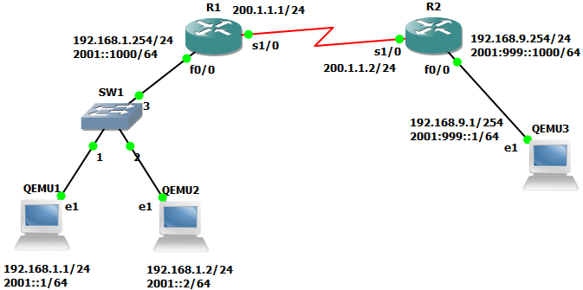

Assessment criteria:
- Successfully capture the packet data in serial link with Wireshark, showing the tunnel, in which IPv6 packet is being encapsulated with IPv4 header.
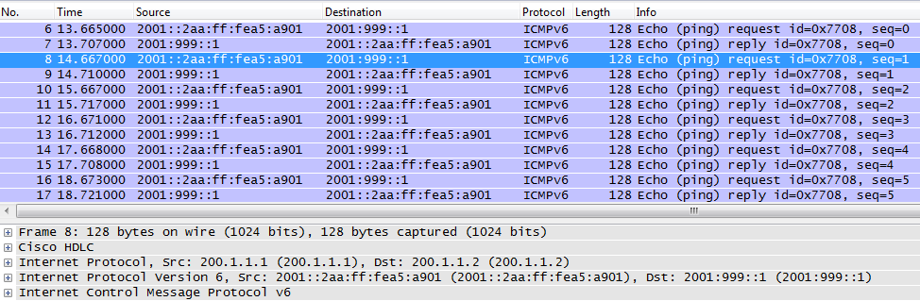

Steps on setting up the network in GNS3:

- You are required to have two image files for this case study in GNS3.
- “c3745-adventerprisek9-mz.124-25.bin” for emulation of Cisco 3745 router.
- “linux-microcore-3.4” for emulation of Linux PC.
- If you see either of the following two dialog boxes, just close it for the time being. We will configure these elsewhere.
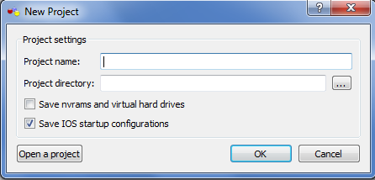
- In the menu, Go to “Edit” → “Preferences”.
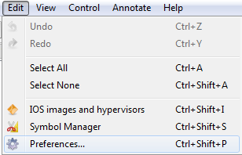

- In the “Preferences” dialog box, click on the “Dynamips” option. Then, click on the “Test” button at the bottom. Make sure that the green message “Dynamips successfully started” is displayed (after 2 or 3 seconds). Don’t modify the default settings of Dynamips.
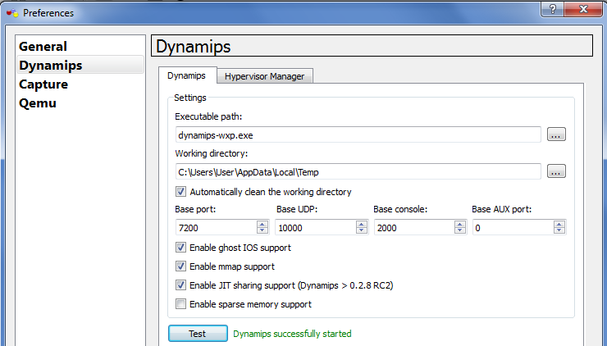

- Click on the “Capture” option, make sure that you have Wireshark installed, and GNS3 is pointing to the correct location of the executable Wireshark file.
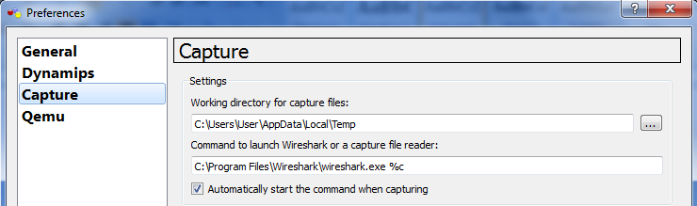

- Click on the “Qemu” option, “General Settings” tab. Then, click on the “Test” button at the bottom. Make sure that the green message “Qemuwrapper, qemu, and qemu-img have successfully started” is displayed (after 2 or 3 seconds). Don’t modify the default settings of “Qemu General Settings”.
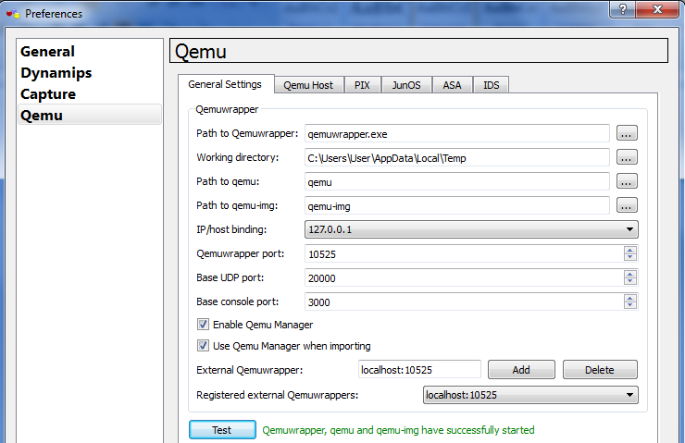

- Click on the “Qemu Host” tab of Qemu option:
- Key in “Linux microcore 3.4” for Identifier name.
- Click on the “…” button, browse and load the “linux-microcore-3.4.img” file. You must have the image file first.
- RAM remains as “128”
- Number of NICs: reduced from ‘6’ to ‘2’.
- NIC model: “e1000”. Meaning Ethernet card.
- Leave it blank for “Qemu Options”.
- Check on “Use KQemu”. QEMU Accelerator (KQEMU) is a driver allowing the QEMU PC emulator to run much faster when emulating a PC on an x86 host.
- After all this (make sure that your configuration matches the following figure), click the “Save” button. (Must do step).
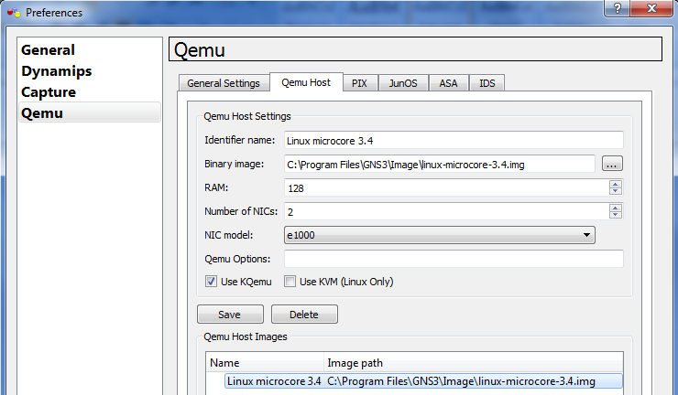

- Press “Ok” at the bottom of Preferences dialog box, and the “Preferences” dialog box will be closed.

- In the menu, go to “Edit”→”IOS images and hypervisors”. After the dialog box has appeared, do the following steps:
- For Image file, click on the “…” button and load the Cisco c3745 IOS file. Again, you must have the file “c3745-adventerprisek9-mz.124-25.bin”.
- After loading the image file, Platform and Model should automatically adjust to the correct model. If not, make sure that the Platform is “c3700” and the Model is “3745”.
- RAM remains as “128”
- Leave it blank for “IDLE PC” if it is blank. If there is a value for “IDLE PC”, leave it as it is. This is an important setting that we will come back to it later.
- Make sure that “Default image for this platform” is checked.
- Click on the “Save” button and then close the dialog box.
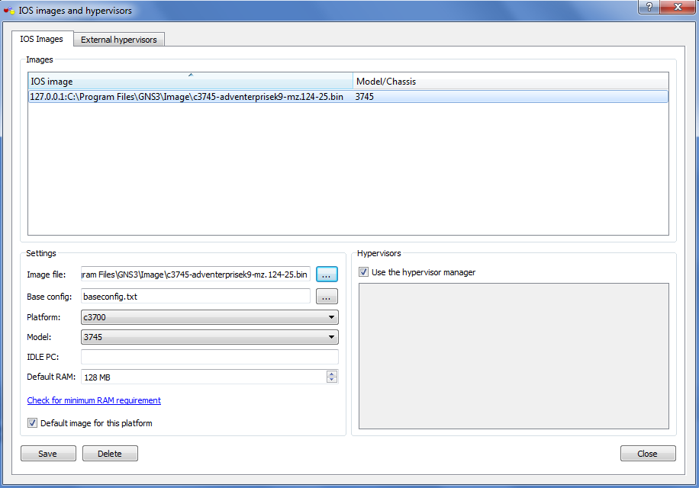

- On the menu, go the “File” → “New blank project”. The “New Project” dialog box will appear. Enter the project name and project directory according to the following figure. Check “Save nvrams and virtual drives” and “Save IOS startup configurations” with √.

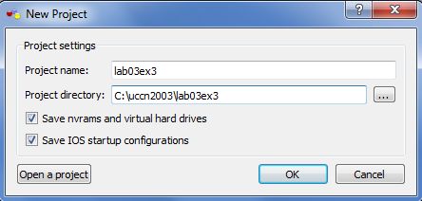

- Click on a “Ether switch” icon (NOT the “EtherSwitch router”, but the one above “ATM bridge”) under Nodes Types and drag it to the workplace pane in the middle and let go. Similarly, drag two “Qemu host” into the workplace pane.

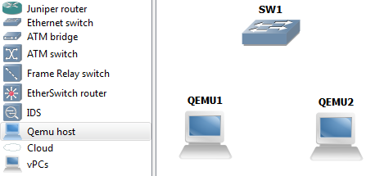
- Go to the icon bar, at the top of the GNS3 Windows, below the menu, click on “Add a link” icon, and choose “FastEthernet”.
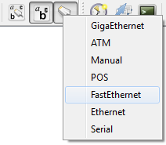

- After that the mouse cursor will turn to “+”, click on “QEMU1” and then “e1”. A line will appear, then click it on “SW1”. A link between “QEMU1” and “SW1” will be formed. Do the same with “QEMU2” and “SW1”. After the two links, go to icon bar, click on “Show interface labels”, the interface label such as “e1” will appear. You may drag those labels around. Click on the  on the icon bar in order to change the mouse cursor “+” back to a normal one. In case, you want to delete the link, right-click on any link and chose “Delete”.
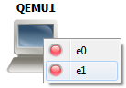 | 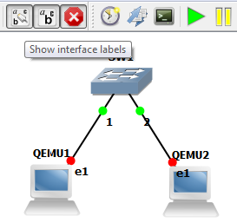 | 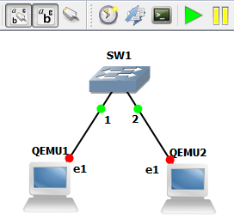 | 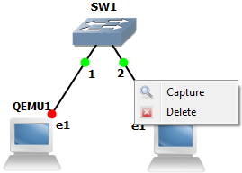

- Right-click on “QEMU1”, choose “Start”, a QEMU box will appear. This QEMU box is a “virtualized Microcore Linux PC”.
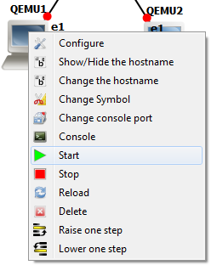 | 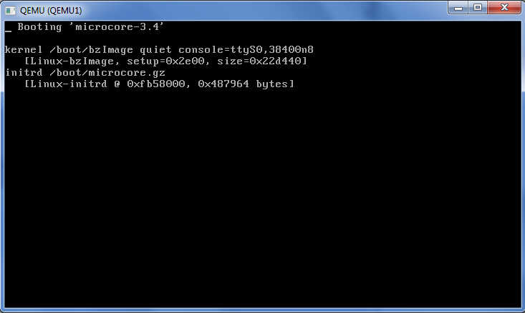

- In GNS3, it is a good practice to turn on the “Windows Task manager” in order to monitor the CPU usage and RAM usage. During the booting up of QEMU1, CPU usage may reach 50% . It is also a good practice that, you “start” the emulated device one by one, so that it will not overload the CPU (CPU usage may reach 100%).

- The following prompt will appear after QEMU1 finish booting up. The booting up takes a minute or two. After booting the CPU usage should drop. DO NOT close the QEMU window at any time, just minimize it. It may not appear again if you close the QEMU window.
tc@box:~$
- Go to the icon bar, click on “Add a note”. You may write the two IP addresses below QEMU1.
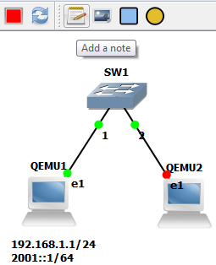

- Click on QEMU window again. If it is QEMU screen is blank with black, just hit the enter key, the prompt will appear. In case the mouse cursor “disappear” after you click the QEMU window, press CTRL-ALT key to make the mouse cursor re-appear.

- QEMU1 is emulating Microcore-Linux, so knowledge in Linux is helpful. Key in the following Linux commands to configure both the IPv4 address (192.168.1.1/24) and the IPv6 address (2001::1/64).
tc@box:~$ sudo su
root@box:~#
root@box:~# ip addr add 192.168.1.1/24 brd + dev eth1
root@box:~# ip -6 addr add 2001::1/64 dev eth1
root@box:~# ip addr show dev eth1

- “sudo su” enable the user to be superuser or privileged mode, and the prompt changes from $ to #. Otherwise, you won’t be able to configure the IP address. “dev” stands for device. “brd” stands for broadcast. You may type “ip addr show dev eth1” to check the IP address configuration.

- In case, you key in the IP address wrongly or configure the IP address for the wrong device. You may delete the IP address with the following commands. Don’t key in the following commands if you have configured the above IP addresses correctly. Instead of address “add”, it is a address “del”.
root@box:~# ip addr del 192.168.1.1/24 brd + dev eth1
root@box:~# ip -6 addr del 2001::1/64 dev eth0

- Repeat the same steps for QEMU2. Right-click on QEMU2, start it. Wait until the prompt appears. Configure the IPv4 address (192.168.1.2/24) and IPv6 address (2001::2/64). Again, don’t close the QEMU2, just minimize it.
tc@box:~$ sudo su  root@box:~#  root@box:~# ip addr add 192.168.1.2/24 brd + dev eth1  root@box:~# ip -6 addr add 2001::2/64 dev eth1  root@box:~# ip addr show dev eth1 | 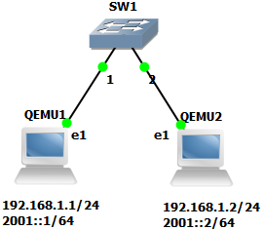

- From QEMU2, ping QEMU1 with IPv4 and IPv6 addresses. If unsuccessful, please troubleshoot. “-c 4” option for ping means there will be four ping (s). If you accidentally enter “ping 2001::1”, press CTRL-C to break out from the ping cycle.
root@box:~# ping 192.168.1.1 –c 4
root@box:~# ping 2001::1 –c 4

- Drag a Router c3700 into the work place pane. (Note: This step won’t work if you have not loaded in the c3745 IOS image previously). Go to icon bar “Add a link”, choose “Manual”. Connect a link from R1 (fa0/0) to SW1(3). Again, click on the on the icon bar in order to change the mouse cursor “+” back to a normal one.
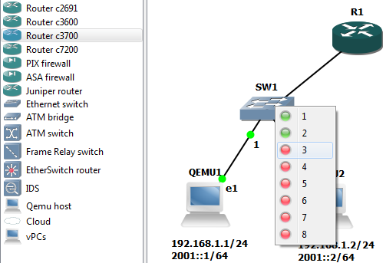

- Right-click on R1, choose “Configure”. The “Node configurator” windows will appear. In the “Node configurator” windows, first click on “R1” option below “Routers c3700”, then click on the “Slots” tab at the right windows. In “slot 1”, use the drop option to choose “NM-4T”. This will provide the router with an extra four serial ports (NM-4T) on top of the original two fast Ethernet ports (GT96100-FE). Press “Ok” button to exit the window.
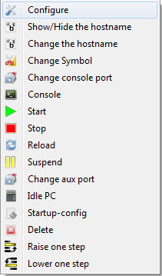 | 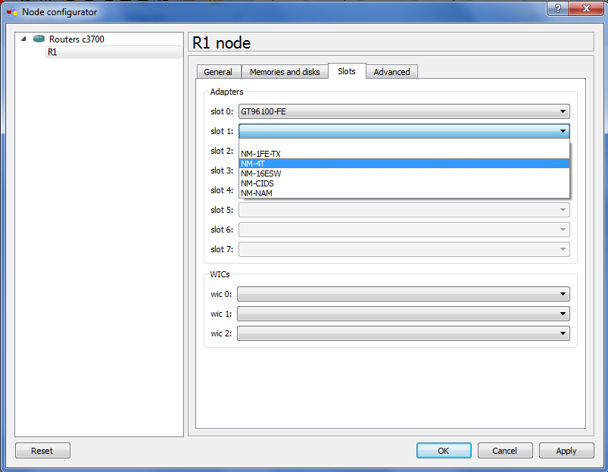

- Make sure that your CPU usage is low. Then right-click on R1 again, choose “start” (the option with little green triangle, “”).

- Double click on R1, the R1 console windows will appear (it is a Putty console screen). As the IOS image is self-decompressing, CPU usage will be more than 50%. Wait until the prompt “R1>” appear. However, the CPU usage may still stay around 50%.
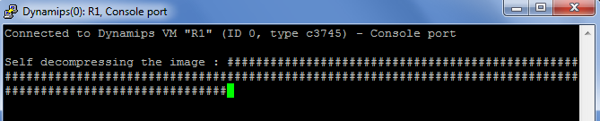
- Right-click on R1 again, choose “Idle PC”. GNS3 will spend a moment calculating an Idle PC value. After the Idle PC calculation, the following dialog box will appear. If you click the drop-down arrow, you see a list of possible “Idle PC” values. Potentially better “Idle PC” values are marked with an asterisk. If no asterisk is present, choose the one with the highest value. For each Idle PC calculation, the list of possible Idle PC values will be different.
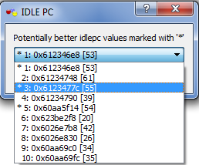 | 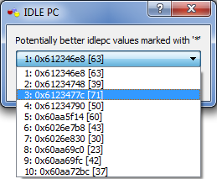

- You will observe that without an Idle PC value, CPU usage will be at or near 50% or even at 100%, but with an Idle PC value, CPU usage will drop to a very low value. The Idle PC value must be set once for each router model. For the next c3745 router, you do not need to set Idle PC unless the CPU usage is high.

- In R1 console screen, enter the following commands to set fa0/0 IPv4 address to 192.168.1.254/24. Then ping 192.168.1.1 and 192.168.1.2.
R1(config)#int fa0/0
R1(config-if)#ip addr 192.168.1.254 255.255.255.0
R1(config-if)#no shut
R1(config-if)#end
R1#ping 192.168.1.1

Type escape sequence to abort.
Sending 5, 100-byte ICMP Echos to 192.168.1.1, timeout is 2 seconds:
.!!!!
Success rate is 80 percent (4/5), round-trip min/avg/max = 4/21/48 ms

- In R1 console screen, enter the following commands to set fa0/0 IPv6 address to 2001::1000/64. Then ping 2001::1 and 2001::2.
R1#conf t
Enter configuration commands, one per line. End with CNTL/Z.
R1(config)#ipv6 unicast-routing
R1(config)#int fa0/0
R1(config-if)#ipv6 enable
R1(config-if)#ipv6 addr 2001::1000/64
R1(config-if)#no shut
R1(config-if)#end
R1#ping 2001::1

Type escape sequence to abort.
Sending 5, 100-byte ICMP Echos to 2001::1, timeout is 2 seconds:
!!!!!
Success rate is 100 percent (5/5), round-trip min/avg/max = 0/8/20 ms
R1#

- Drag another Router c3700 into the work place pane (R2). Right-click on R2, choose “Configure”, insert “NM-4T” in “slot 1”. Press “Ok”.
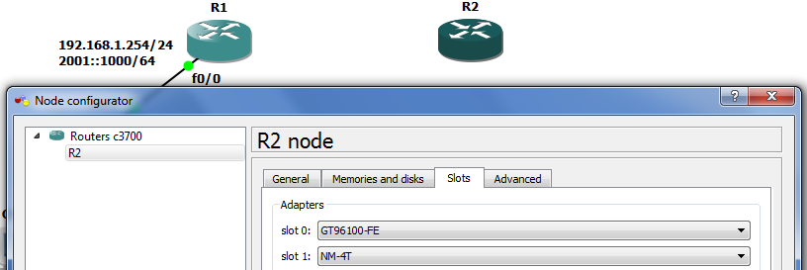

- Drag in QEMU3 and connect the rest of the network as the following figure. Go to icon tool bar “Add a link”, choose “Manual”. Link s1/0 of R1 to s1/0 of R2. Link fa0/0 of R2 to e1 of QEMU3. Do not start both R2 and QEMU3 in this moment. It will overload the CPU. It should be turned or started one at a time.
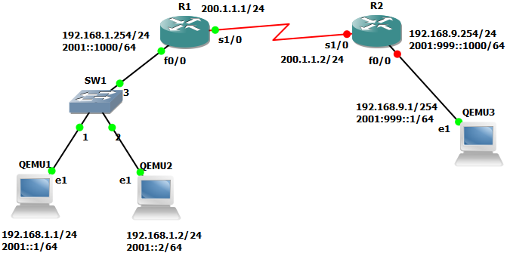

- Right-click on QEMU3 and choose start. The QEMU 3window will appear. Now, you should have three QEMU windows. Wait till QEMU3 finish booting, and enter the following commands for IP address configuration (IPv4 = 192.168.9.1/24; IPv6 = 2001:999::1/64).
tc@box:~$ sudo su
root@box:~#
root@box:~# ip addr add 192.168.9.1/24 brd + dev eth1
root@box:~# ip -6 addr add 2001:999::1/64 dev eth1
root@box:~# ip addr show dev eth1

- Right-click on R2 and choose start. This time you don’t need to set Idle PC because it has been set previously. Double-click on R2 to bring up the R2 console window. Wait until the prompt appears and enter the following commands for IPv4 address configuration.
R2(config)#int fa0/0
R2(config-if)#ip addr 192.168.9.254 255.255.255.0
R2(config-if)#no shut
R2(config-if)#end
R2#ping 192.168.9.1

- Enter the following commands for ipv6 address (2001:9::1000/64) configuration.
R2(config)#ipv6 unicast-routing
R2(config)#int fa0/0
R2(config-if)#ipv6 enable
R2(config-if)#ipv6 addr 2001:999::1000/64
R2(config-if)#no shut
R2(config-if)#end
R2#ping 2001:999::1
- Enter the serial IPv5 addresses for both R1 and R2 (200.1.1.1, 200.1.1.2).
R2(config)#int s1/0
R2(config-if)#ip addr 200.1.1.2 255.255.255.0
R2(config-if)#clock rate 128000
R2(config-if)#no shut

R1(config)#int s1/0
R1(config-if)#ip addr 200.1.1.1 255.255.255.0
R1(config-if)#clock rate 128000
R1(config-if)#no shut
R1#ping 200.1.1.2
Ping is successful.

- Setting the default gateway for QEMU1, QEMU2, and QEMU3. In Linux, unlike Windows, the default gateway is configured separately from the IP address configuration.
QEMU1 & QEMU2:
root@box:~# ip route add default via 192.168.1.254
root@box:~# ip route show
root@box:~# ip route add default via 2001::1000
root@box:~# ip -6 route show
QEMU3:
root@box:~# ip route add default via 192.168.9.254
root@box:~# ip route show
root@box:~# ip route add default via 2001:999::1000
root@box:~# ip -6 route show

- Enter the following ip route command in R2, so that QEMU1 and QEMU2 can ping 200.1.1.2.
R2(config)#ip route 192.168.1.0 255.255.255.0 200.1.1.1

- Configure a IPv6 tunnel with the following commands. “int tunnel0” = Moves to tunnel interface configuration mode. “tunnel source s1/0” = Specifies the source interface type and number for the tunnel interface. “tunnel destination” = Specifies the destination IPv4 address for the tunnel interface. “tunnel mode ipv6ip” = Specifies a manual IPv6 tunnel—specifically that IPv6 is the passenger protocol and IPv4 is both the encapsulation and protocol for the IPv6 tunnel. “ipv6 unnumbered” = An unnumbered interface does not have an IPv6 address assigned to it.
R1(config)#int tunnel0
R1(config-if)#tunnel source s1/0
R1(config-if)#tunnel destination 200.1.1.2
R1(config-if)#tunnel mode ipv6ip
R1(config-if)#ipv6 unnumbered fa0/0
R1(config-if)#exit
R1(config)#ipv6 route 2001:999::/64 tunnel0

R2(config)#int tunnel0
R2(config-if)#tunnel source s1/0
R2(config-if)#tunnel destination 200.1.1.1
R2(config-if)#tunnel mode ipv6ip
R2(config-if)#ipv6 unnumbered fa0/0
R2(config-if)#exit
R2(config)#ipv6 route 2001::/64 tunnel0
- Right-click on the serial link , choose “Capture”. The capture dialog box appear, and choose R1 s1/0 (encapsulation:HDLC). Wireshark will start automatically. However, close Wireshark after it have started.
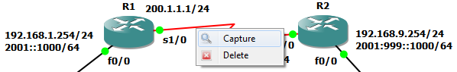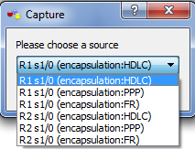

- In QEMU1, ping 2001:999::1. It should be successful. If not, you need to troubleshoot the network.
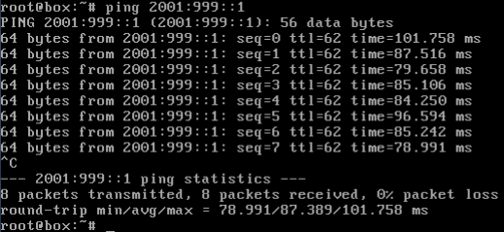

- Right-click on the serial link again. This time, choose “Start Wireshark”.
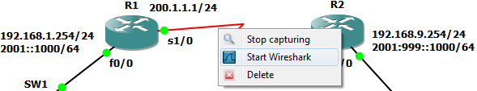

- The Wireshark will start again, scroll down the portion where you can see the ICMPv6. Click on one of the ICMPv6 entry and you should see there is the IPv6 packet encapsulated with a IPv4 header.

- Finally, copy running-config files of both R1 and R2 to startup-config. Save the whole project file.
R1#copy run start
R2#copy run start

- Some useful ipv6 troubleshooting commands for Cisco routers.
R1#show ipv6 interface brief  R1#show ipv6 neighbors  R1#show ipv6 protocol | R1#show ipv6 route  R1#show ipv6 traffic  R1#show ipv6 tunnel
Exercise 4: IPv6 Tunneling

Build a network based on the following figure with the following specifications.
- Extend on the network of case study #3 and add in an extra R3. R3 is a router with IPv4 address only.
- IPv6 subnet 2001::/64 can communicate with IPv6 subnet 2001:999::/64 via an IPv6 tunnel passing through the IPv4 subnet 200.1.1.0/24 and 202.2.2.0/24.
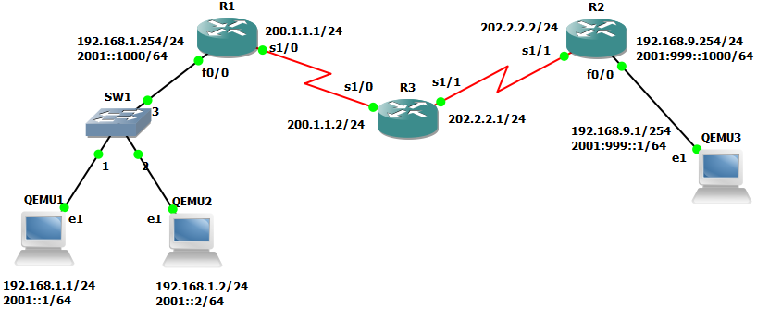
Assessment criteria:
- Successfully capture the packet data in serial link with Wireshark, showing the tunnel, in which IPv6 packet is being encapsulated with IPv4 header, delivering the IPv4 packets from 200.1.1.1 to 200.1.1.2, indicating that QEMU1 has successfully ping QEMU3 using IPv6 address.
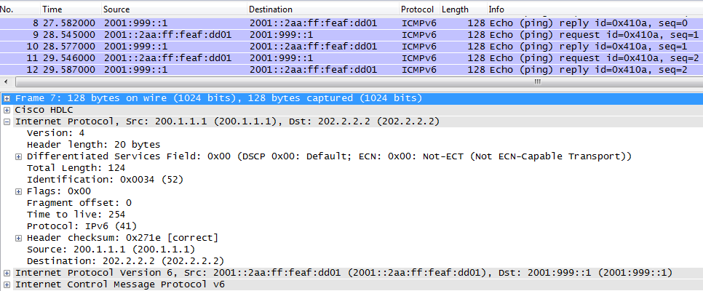
Hints on the extension of R3:
- Set the IPv4 addresses of R3 and IPv4 routes.
- Make sure 192.168.1.1 can ping 202.2.2.2 first.
- Erase all the tunnel commands in previous exercises and refer to the commands below.
R1(config)#int tunnel0  R1(config-if)#tunnel source s1/0  R1(config-if)#tunnel destination  202.2.2.2  R1(config-if)#tunnel mode ipv6ip  R1(config-if)#ipv6 unnumbered fa0/0  R1(config-if)#exit  R1(config)#ipv6 route 2001:999::/64  tunnel0  R1(config)#exit | R2(config)#int tunnel0  R2(config-if)#tunnel source s1/1  R2(config-if)#tunnel destination  200.1.1.1  R2(config-if)#tunnel mode ipv6ip  R2(config-if)#ipv6 unnumbered  fa0/0  R2(config-if)#exit  R2(config)#ipv6 route 2001::/64  tunnel0  R2(config)#exit

